**JMeter Setup**

1. Download the Apache JMeter application (Note, you will need to have Java installed on your machine). <https://jmeter.apache.org/download_jmeter.cgi>

To check if java is installed, open the command line and type “java -version”. If not found, then you will need to install java. <https://www.oracle.com/java/technologies/javase-jdk15-downloads.html>

1. Copy the “mssql-jdbc-8.2.2.jre14.jar” file into the JMeter “lib” directory.



1. Open the JMeter application by navigating to the “bin” directory where JMeter was installed and clicking on the “jmeter.bat” file.

This opens the JMeter application which allows you build and run the JMeter test cases using the GUI interface.

It is best practice to run the JMeter test using the command line. Below is an example execution of a test case.

Example command to run the JMeter test using Command Line

Jmeter -n -t "Test Scripts\Test DWTC-5 TPCDS 100GB synapsedev1_Sequential.jmx" -f

1. When creating test scripts in a JMeter, a “jml” file is created that contains the definition of the test case. This repo contains sample jml files that contains the test cases to run the TPC-DS and TPC-H queries. The standard tpc queries have been updated so they can run within a Synapse dedicated pool instance. Note, the queries in the jml file are scripted to run using the schema that was created in the Synapse SQL Scripts folder in this repo.
2. Updates to the jml file. Connection to the dedicated pool.
3. Place the SparkJDBC42.jar, hive-jdbc-4.0.0-SNAPSHOT-standalone.jar, and mssql-jdbc-8.2.2.jre13.jar file in the **lib** directory. Place the hive-jdbc-4.0.0-SNAPSHOT-standalone.jar file in the **lib/ext** directory.
   1. **hive-jdbc-4.0.0-SNAPSHOT-standalone.jar** – used for HDInsight hive queries
   2. **hive-jdbc-2.1.0-SNAPSHOT-standalone.jar** – used for HDInsight spark queries
   3. **mssql-jdbc-8.2.2.jre13.jar** – Synapse dedicated and serverless queries
   4. **SparkJDBC42.jar** – Databricks spark queries

# JMeter JDBC Connection Configurations

## Databricks Cluster

**Database URL:** jdbc:spark://adb-1487981951669006.6.azuredatabricks.net:443/default;transportMode=http;ssl=1;httpPath=sql/protocolv1/o/1487981951669006/0622-195936-penes977;AuthMech=3

**JDBC Driver class:** com.simba.spark.jdbc.Driver

**Username:** token

**Password:** <User Assigned Token>

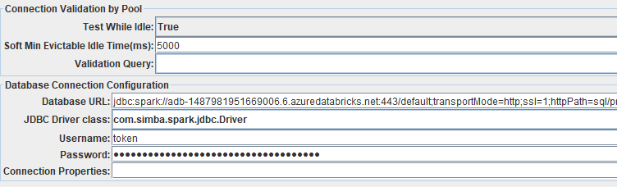

## Databricks SQL Analytics Endpoint

**Database URL:** jdbc:spark://adb-1487981951669006.6.azuredatabricks.net:443/default;transportMode=http;ssl=1;AuthMech=3;httpPath=/sql/1.0/endpoints/c30169e5a5f50a2a;

**JDBC Driver class:** com.simba.spark.jdbc.Driver

**Username:** token

**Password:** <User Assigned Token>

## HDInsight

**Database URL:** jdbc:hive2://hdibrmyers.azurehdinsight.net:443/;transportMode=http;ssl=true;httpPath=/sparkhive2

**JDBC Driver class:** org.apache.hive.jdbc.HiveDriver

**Username:** admin

**Password:** <Password>

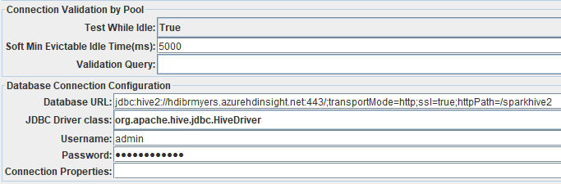

## Synapse Dedicated Pool

**Database URL:** jdbc:sqlserver://synapseworkspace.sql.azuresynapse.net:1433;database=SQLPoolDW;

**JDBC Driver class:** com.microsoft.sqlserver.jdbc.SQL ServerDriver

**Username:** LoadingUser

**Password:** <Password>

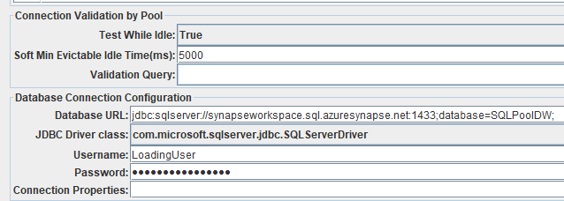

## Synapse Serverless Pool

**Database URL:** jdbc:sqlserver://synapseworkspace-ondemand.sql.azuresynapse.net:1433;database=SQLPoolDW;

**JDBC Driver class:** com.microsoft.sqlserver.jdbc.SQL ServerDriver

**Username:** LoadingUser

**Password:** <Password>

